

WMPP Fabric Data Solution
  - High level architecture and key changes
27 October 2026
The WMPP solution uses Microsoft Fabric to turn current and historical placement extracts into governed reporting data. Raw data, conformed entities and reporting tables have separate responsibilities, supported by common load and quality controls. This summary describes the implemented design and the main changes; deployment, refreshed results and client acceptance require separate confirmation.

Solution flow
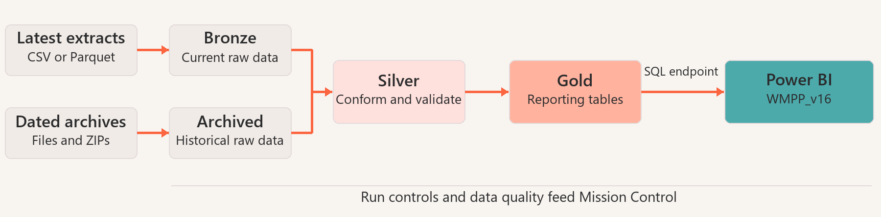
The maintained WMPP_v16 model uses Import partitions through the Lakehouse SQL analytics endpoint. Its refresh must follow the required Gold processing. A move to Direct Lake requires a separately verified deployment decision.

Layer responsibilities
Layer | Responsibility
Bronze | Current raw extracts with source, export and ingestion metadata.
Archived | Dated source extracts retained for controlled historical replay.
Silver | Contract-driven types, deduplication, validation and reusable business enrichment.
Gold | Managed reporting tables for referrals, offers, IPAs, providers and homes, with dimensions, bridges and monthly snapshots.
Monitoring | Job and table load history, schema drift, quality results and retry controls, consumed by Mission Control.

Main architecture changes
- Two controlled processing streams. The live runner processes latest extracts through Bronze, Silver, quality checks and Gold. The archive runner separates archive collection from explicit replay, so collecting history does not itself rebuild current reporting data.
- Consistent monthly history. Replay chooses the final available export date in each month and uses the latest eligible export for each table on or before that date. Monthly referral snapshots support comparison without inventing daily history.
- Governed schema and business rules. A central schema contract controls types, primary keys and approved relationships. Shared processing handles schema drift, deduplication and quality checks; cross-table business enrichment remains separate from source-conformed entities.
- Gold tables for reporting. Core Gold facts are materialised as managed Delta tables to support discovery by downstream reporting. The public reporting names are retained, with fact_ipa as the active IPA fact. Power BI holds semantic aggregations and report interaction logic.
- Broader reporting with operational separation. WMPP_v16 supports referral and provider exploration, drillthrough, IPA evidence, home document expiry and historical comparisons. Mission Control separately reports pipeline status, timings, load volumes, schema changes and quality results.

Operation and security
Central setup owns the control tables, and both runners use shared notebook utilities. Load status, export dates and reload flags allow completed work to be skipped and failed or explicitly selected work to be retried. Monitoring reporting is refreshed after final job status is recorded. Historical replay and guarded resets are recovery tools; production retention, backups and disaster recovery still need an agreed operating policy.
Fabric and Power BI access must follow least privilege. The semantic model contains dynamic row-level security and a separate global-summary design. Business relationships use record identifiers; user-facing reference numbers remain display fields. Quality exceptions retain limited key evidence, and actual user access, export permissions and regional boundaries require acceptance testing.

Decisions before operational sign off
- Confirm Fabric execution, Gold availability, Power BI refresh and reconciled business totals, then complete report and security testing with authorised users.
- Agree ownership, scheduling, retention, backup and restore procedures, recovery targets and support arrangements.
- Resolve document-to-home ownership and required-document rules. Payment tracking, full audit history, notification outcomes and unapproved provider scoring remain dependent on source data or business decisions.

